Nombre ____________________________________________ Hora _____ Fecha _________________

**PROYECTO – Diseño de una ciudad**

**A mi hijo Ethan le gustan los carros pequeños. A veces, dibujo ciudades y calles pequeñas para sus carritos Matchbox. Luego Ethan y yo jugamos. A Ethan le gustan mucho las ciudades pequeñas. En este proyecto, necesitas diseñar una ciudad pequeña para Ethan.**

**PAUSA: (En inglés, en 10 palabras or menos—What do you need to do in this project?)**

**COMPETICIÓN- Ethan va a ver todas las ciudades. Después, ÉL va a decidir - ¿cuál es la mejor (más buena) ciudad?**

**PREMIO- Si tú ganas, Ethan va a jugar carros contigo y 3 amigos de la clase. Él habla español. Así vas a jugar a carros con Ethan en español y ver un episodio de Thomas el Tren con Ethan durante nuestra clase.**

¿Qué información necesitas para diseñar una ciudad para Ethan? ¿Cuáles preguntas tienes?

-¿Información acerca de Ethan?

-¿Vocabulario?

-¿Gramática?

**SPECIFIC STEPS:**

**DUE DATE!!!!!!!! ____________________________________________________________________**

1. On a separate sheet, draw and label **a minimum of** **15 places/things** that are located in your city.

You may *draw* your city, *use clip art* printed off of the computer/cut outs from a magazine, or *combine* art and computer/magazine generated images.

* Title your map with the name of your city
* Label all buildings with their name and what type of building they are (ex. Starbucks- café)
* Make sure your map is neat and visually appealing to a child
* Be sure to include elements in your map that reflect Ethan’s dual nationality

**DUE DATE!!!!!!!!! ____________________________________________________________________**

2. Prepare a report about your city for Ethan and I to review. As the city planner, you will need to present

your information in **COMPLETE SPANISH SENTENCES** so that Ethan clearly understands your city design. **BE SURE TO HIGHLIGHT ANY WORDS YOU HAD TO LOOK UP.** (www.wordreference.com)

* Tell the name of your city
* Tell why your city is «*la mejor*» (más buena)
* Specifically talk about 8 buidings/places in your city
  + Give the function and name of the building (EX: My city has a…/There is a…. It is called…)
  + Tell the position of the building relative to something else (EX: It is near/to the left of…etc)
  + Tell what Ethan *is going to* do at each place (EX: Here Ethan is going to …)
  + Identify a minimum of 3 elements that reflect Ethan’s birthplace

**DUE DATE!!!!!!! ______________________________________________________________________**

Be prepared to *present and promote* your city to a small group and *offer feedback* to group members on their city design. Rehearse your presentation, vocabulary, and sentence starters. You will not NOT be able to use your written report in your presentation, but you should use your city plan.

NOMBRE Y APELLIDOS: ___________________________________________ BL: _________

**INFORME FORMAL**

(NOMBRE DE LA CIUDAD)

1. ______________________________________________________________________

(MI CIUDAD—LA MEJOR) **COMPLETE SENTENCES/ SPANISH/ HIGHLIGHT ANY WORDS YOU LOOKED UP ONLINE**

1. ______________________________________________________________________

______________________________________________________________________ ______________________________________________________________________ ______________________________________________________________________ ______________________________________________________________________ ______________________________________________________________________

(8 EDIFICIOS IMPORTANTES) **COMPLETE SENTENCES/ SPANISH/ HIGHLIGHT ANY WORDS YOU LOOKED UP ONLINE**

1. ______________________________________________________________________ ______________________________________________________________________ ______________________________________________________________________ ______________________________________________________________________ ______________________________________________________________________

Nombre y función de lugares en tu plan, dónde está el lugar, actividad de Ethan en el futuro

1. ______________________________________________________________________ ______________________________________________________________________ ______________________________________________________________________ ______________________________________________________________________ ______________________________________________________________________
2. ______________________________________________________________________ ______________________________________________________________________ ______________________________________________________________________ ______________________________________________________________________ ______________________________________________________________________
3. ______________________________________________________________________ ______________________________________________________________________ ______________________________________________________________________ ______________________________________________________________________ ______________________________________________________________________

Nombre y función de lugares en tu plan, dónde está el lugar, actividad de Ethan en el futuro

1. ______________________________________________________________________ ______________________________________________________________________ ______________________________________________________________________ ______________________________________________________________________ ______________________________________________________________________
2. ______________________________________________________________________ ______________________________________________________________________ ______________________________________________________________________ ______________________________________________________________________ ______________________________________________________________________
3. ______________________________________________________________________ ______________________________________________________________________ ______________________________________________________________________ ______________________________________________________________________ ______________________________________________________________________
4. ______________________________________________________________________ ______________________________________________________________________ ______________________________________________________________________ ______________________________________________________________________ ______________________________________________________________________

Nombre y función de lugares en tu plan, dónde está el lugar, actividad de Ethan en el futuro

(MÍNIMO DE 3 DETALLES QUE REFLEJAN LA PRIMERA CULTURA DE ETHAN)

**COMPLETE SENTENCES/ SPANISH/ HIGHLIGHT ANY WORDS YOU LOOKED UP ONLINE**

1. ________________________________________________________________

________________________________________________________________

1. ________________________________________________________________

________________________________________________________________

1. ________________________________________________________________

**_________________________________________________________________________________**

ALGO MÁS QUE QUIERES INCLUIR

________________________________________________________________________________________________

**________________________________________________________________________________________________**

**________________________________________________________________________________________________**



CULTURAL POINTS:

10 My city includes 3 elements that reflect Ethan’s Honduran heritage and clearly explains this connection in the *informe*

9 My city includes 3 elements that reflect Ethan’s Honduran heritage, but the connection is not clearly explained for all 3

8 My city includes 3 elements that reflect Ethan’s Honduran heritage, but the connection is minimally explained

7 There are insufficient elements that reflect Ethan’s Honduran heritage and the *informe* needs more explanation

6 There is minimal representation of Ethan’s Honduran heritage and little or no explanation

0 There is no representation of Ethan’s Honduran heritage

**PREPARACIÓN para mi presentación:**

Be prepared to:

* + - *present and promote* your city to a small group
    - and *offer feedback* to group members on their city design

**¡NO USAMOS LOS INFORMES DURANTE NUESTRA PRESENTACIÓN AL GRUPO! Sólo usamos los planes de la ciudad.**

**PAUSA: (EN INGLÉS en 10 palabras o menos: What do you know about the oral presentational piece to your group?)**

**In your presentation, WHAT KIND OF SENTENCE STARTERS MIGHT YOU USE to present and promote your city?**

______________________________________________________________________

______________________________________________________________________ ______________________________________________________________________ ______________________________________________________________________ ______________________________________________________________________ ______________________________________________________________________

**After your presentation, WHAT KIND OF SENTENCE STARTERS MIGHT YOU USE to offer others feedback about their cities?**

**(EX: I like your ____ because_____./ Why do you have _____ in your city?/ In my opinion, you need ____ because _____./etc).**

______________________________________________________________________

______________________________________________________________________ ______________________________________________________________________ ______________________________________________________________________ ______________________________________________________________________ ______________________________________________________________________

**What additional questions or concerns do you have?**

**DATE: _____________________**

**My Feedback**

|  |  |  |  |  |  |  |  |  |  |
| --- | --- | --- | --- | --- | --- | --- | --- | --- | --- |
| **NAME** | **Understandable** | **Content and use of details** | **Original and varied vocabulary** | **Self corrects errors** | **Speaking pace** | **Follow up questions and feedback** | **Application of grammatical knowledge** | **STRENGTH** | **FOCUS FOR GROWTH** |
|  |  |  |  |  |  |  |  |  |  |
|  |  |  |  |  |  |  |  |  |  |
|  |  |  |  |  |  |  |  |  |  |
|  |  |  |  |  |  |  |  |  |  |
|  |  |  |  |  |  |  |  |  |  |

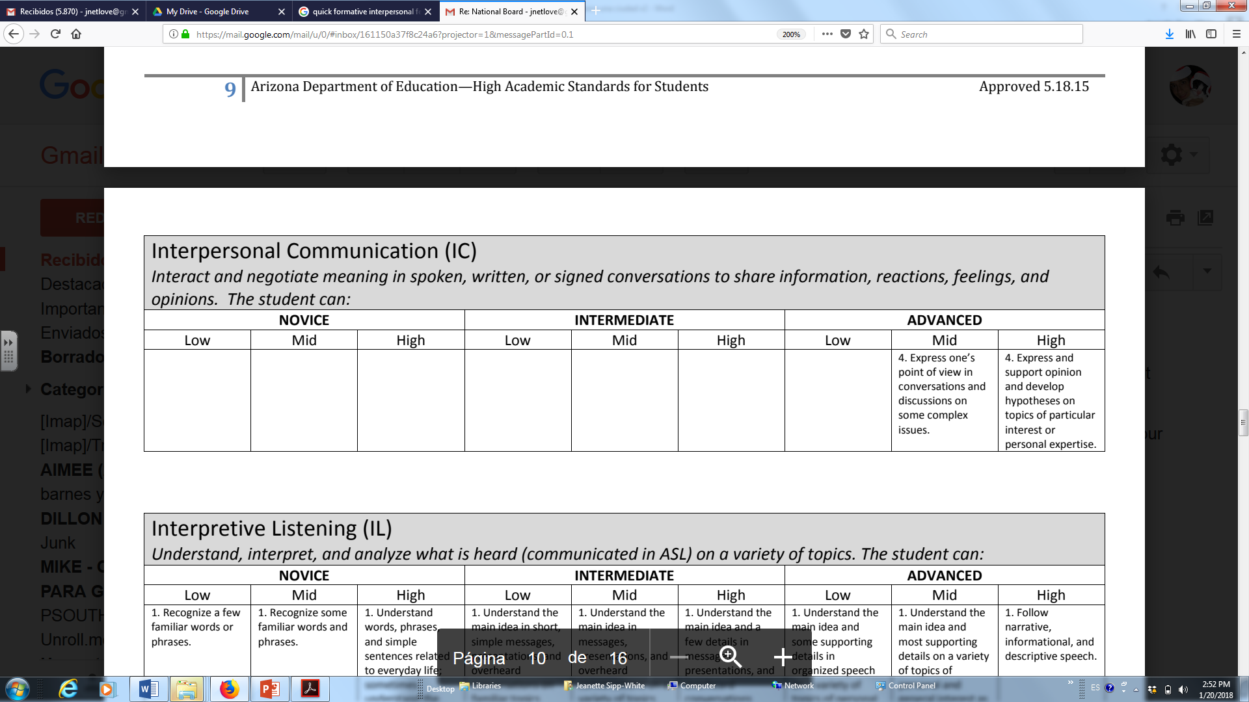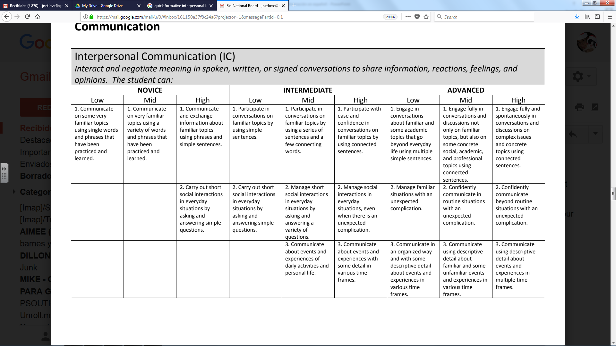

SINGLE WORDS PHRASES PHRASES SIMPLE

**(4) (6)** AND SENTENCES

SIMPLE (CREATES)

SENTENCES

(MEMORIZED) WITHOUT

**(7)** DETAILS **(8)**

WITH SOME

DETAILS **(9)**

WITH VARIETY OF

*NON* REPEATING DETAILS **(10)**

**COMENTARIOS:**

**NOMBRES Y APELLIDOS: _____________________________________________________________ FECHA: _______________**

**STUDENT REFLECTION SHEET REGARDING SPEAKING ABOUT ______________________________________________**

**How do I feel that I am performing in each of these categories?**

|  |  |  |  |  |  |  |  |  |
| --- | --- | --- | --- | --- | --- | --- | --- | --- |
| **Understandable**  **(Would a native speaker understand my Spanish? Are my thoughts comprehensible?**  **Why or why not?)** | **Content and use of details**  **(Do I expand my thoughts? Am I repetitive in the sentences I make or the questions I ask?)** | **Original and varied vocabulary**  **(Do I tend to use the same words over and over again? Do I use a variety of words from the unit? Do I use my own personal vocabulary?)** | **Self corrects errors**  **(Do I correct myself when I hear myself making an error?)** | **Speaking pace**  **(Do I speak fluidly? Do I have a lot of pauses in my speech?)** | **Follow up questions and feedback**  **(Do I ask questions in my group? Are they repetitive? Do I offer suggestions or complements to group members?**  **Are they repetitive?)** | **Application of grammatical knowledge**  **(Do I conjugate verbs when I speak? Do I make adjectives masculine/ feminine/ singular/ plural when I speak?)** | **STRENGTH**  **(What am I doing well? What should I continue to do?)** | **FOCUS FOR GROWTH**  **(Where do I need to improve? Specifically, what might I do to improve in this area?)** |
|  |  |  |  |  |  |  |  |  |

**NOMBRE Y APELLIDOS: ___________________________________________________ FECHA: _____________________**

